Problem 1

**Given:**

A table of time and odometer readings.

**Find:**

Time intervals, distance, and speed for each time reading.

**Diagram:**

**Theory:**

**Assumptions:**

The car works for the entirety of the experiment.

**Solution:**

first time interval:

first distance 1:

first average speed 1:

Problem 2

**Given:**

Position and time data of a moving ball

**Find:**

The velocity and acceleration of the ball at t=2, 3, 4, 5 and 6 seconds

**Diagram:**

**Theory:**

Forward finite difference:

Backward finite difference:

Center finite difference:

**Assumptions:**

There is a ball and the ball is moving

**

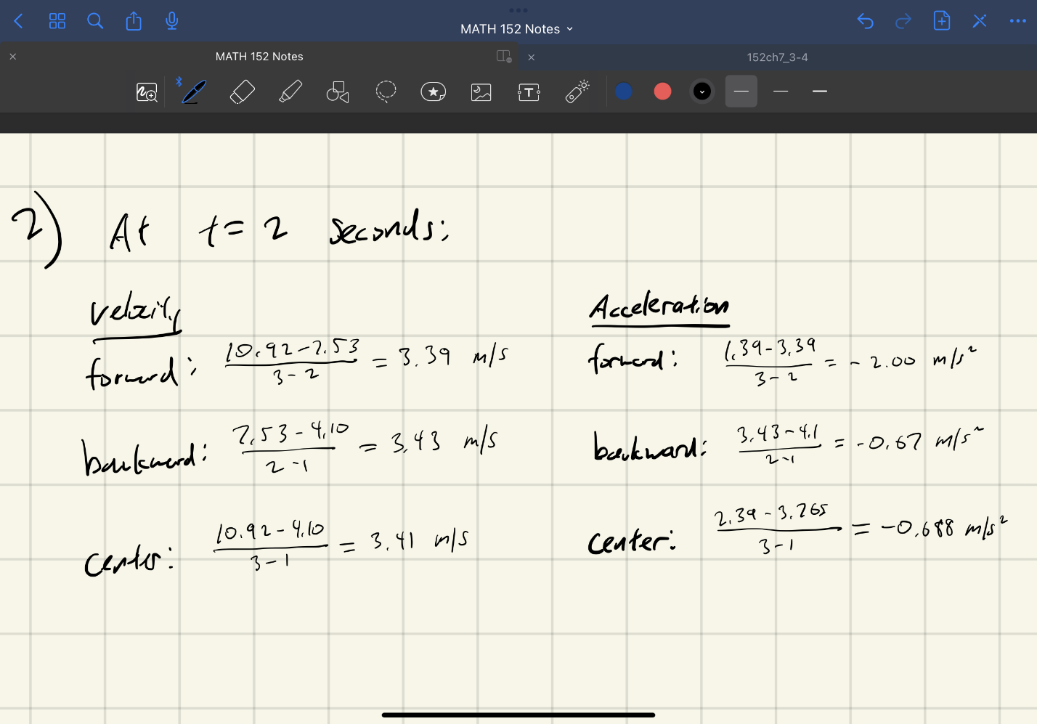

Problem 3

**Given:**

A table of distance and air velocity measurements.

**Find:**

The shear stress of a surface at distances y = 0.006, 0.012, and 0.018 meters.

**Diagram:**

**Theory:**

Newton’s viscosity law:

Second order center first finite difference:

**Assumptions:**

Dynamic velocity µ is constant.

**Solution:**

**Shear stress 𝜏 at y=0.006 m:**

Higher order finite differences find higher order derivatives of a function, so the change would be the slope of the function.

Problem 4

**Given:**

The function

**Find:**

1. Numeric estimates of the derivative of the function f(x) using forward, backward, and centered finite differences and step size
2. The percent error between the estimated values and the true value
3. The value of needed for the forward and backward finite differences to reach the same percent error as the centered finite difference using the original

**Diagram:**

N/A

**Theory:**

Forward finite difference:

Backward finite difference:

Center finite difference:

Percent error:

**Assumptions:**

The true value of the derivative at x=1.5 is accurate

**Solution:**

